LINCOLN LODGE NO. 11
Free and Accepted Prince Hall Masons
1356 Madison Street
Alexandria, VA

2021 – 2022 Trestle Board and Roster
Payton R. Dade Sr.
Worshipful Master

Regular Communications: 1st & 3rd Tuesdays October – June
1st Tuesdays July – September

Masonic Year 2021 - 2022
GIVING HONOR TO
The Honorable Richard Townes
Avarett Union Lodge #235
Most Worshipful Grand Master
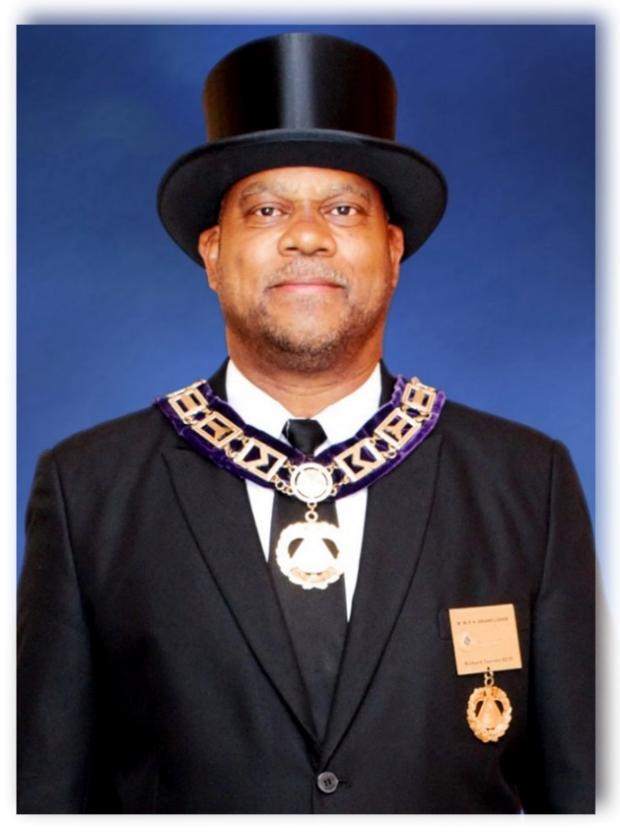
Most Worshipful Prince Hall Grand Lodge of Virginia, F.&A.M. Inc.

Right Worshipful Deputy Grand Master – Donald S. Wilson
Right Worshipful Senior Grand Warden – Beverly W. Morgan, Jr.
Right Worshipful Junior Grand Warden – George T. Cutler
Right Worshipful Grand Treasurer – James E. Watkins, Jr.
Right Worshipful Grand Secretary – Stevie R. Gray
Right Worshipful Senior Grand Deacon – Edward E. Lattimore III
Right Worshipful Junior Grand Deacon – Antonio Pride

Worshipful Master Payton R. Dade Sr.

Senior Warden – Bro. Larry Hinton
Junior Warden – Bro. Michael A. Petty
Treasurer – WPM Eric T. Richardson
Secretary – WPM Devery S. Travers
Senior Deacon – Bro. Maury Walker
Junior Deacon – Bro. Ronde Benton.
Senior Steward – Bro. Mericko L. Marlowe
Junior Steward – Bro. Todd Jones
Chaplain – Bro. Kenneth Gilbert
Tiler – Bro. Preston A. Wells Jr.
Assistant Secretary – DDGM Jimmie CJ James
Assistant Treasurer – WAGS Keith Williams
Historian – WPM Preston A. Wells Sr.
Marshall – Bro. Brandon Hanson.
LINCOLN LODGE NO. 11
TRUSTEES

2021 – 2022

PDDGM Robert L. Steele (Chair)
WPM Willie E. Gregg
WPM Preston Wells, Sr.
WPM Lorenzo Nichols
WPM Nelson J. Perry
WPM John E. Fennell
WPM Devery Travers

2021-2022 COMMITTEES

Collation
WM Payton R. Dade Sr. (Chair)
SW Larry Hinton
JW Michael Petty

Information Technology
JW Michael Petty (Chair)
WPM Eric T. Richardson
DDGM Jimmie CJ James
Bro. Ronde Benton
Bro. Brandon Hanson

Scholarship
WPM Devery S. Travers (Chair)
SD Maury Walker
WPM Eric T. Richardson
JW Michael Petty
Bro. Ronde Benton

Activity
JW Michael Petty (Chair)
SS Mericko L. Marlowe
JS Todd Jones
JD. Preston Wells Jr.
Bro. Ronde Benton

Audit
SD Maury Walker (Chair)
JD Preston A. Wells Jr.
SW Larry Hinton
WPM Keith Williams
Bro. Ronde Benton

Sick and Distressed
WM Payton R. Dade Sr. (Chair)
SW Larry Hinton
JW Michael Petty
Chaplin Kenneth Gilbert
WPM Preston Wells, Sr
WPM Willie Brown
PDDGM Robert L. Steele
ACCFC WPM Richard L. Williams

By Laws
PPDDGM Robert L. Steele (Chair)
WPM Derrick McCain
SW. Larry Hinton
WPM Willie Gregg

Investigation
SW Larry Hinton (Chair)
JD Ronde Benton
JW Michael Petty
WPM Eric T. Richardson
Bro. David Rapelyea

Ritualistic
WPM Willie E. Gregg (Chair)
WPM Nelson Perry
WPM Devery S. Travers
SW Larry Hinton
WPM Eric T. Richardson

Budget
WPM Devery S. Travers (Chair)
WPM Eric T. Richardson
PDDGM Robert L. Steele
WPM Lorenzo Nichols
JW Michael Petty

Advisory Council

WPM Willie Brown
WPM Aaron Dowdell
WPM John E. Fennell
WPM Leroy Foster
WPM Felton Gilliam
WPM Willie E. Gregg
WPM Frankey Hicks, Sr.
DDGM Jimmie C.J. James
WPM Danny Lambouths Jr.
WPM Derrick McCain

WPM Lorenzo Nichols
WPM Nelson Perry
WPM Eric T. Richardson
PDDGM Robert L. Steele
WPM Corey Tate
WPM Devery S. Travers
WPM Reginald B. Washington
WPM Preston Wells, Sr.
WAGS WPM Keith Williams
ACCFC WPM Richard L. Williams

Membership Roster
Alex Armour
9435 Lorton Market St.
Lorton, VA 22079
(571) 279-4864(C)

Thorn Rashard Bacote
228 Sheridan Avenue
Unit 52 F
Fort Myer, Virginia 22211
(843) 496-4333 (C)

Ronde Benton
2946 Cambridge Dr
Woodbridge, Va 22192
571-253-0472 (C)

Willie Brown, WPM
116 South Jordan Street
Alexandria, VA 22304
(703) 212-9537 (H)
(703) 786-5310 (C)

John T. Chapman
112 West Taylor Run Parkway
Alexandria, VA 22314
(703) 888-0261 (H)
(571) 236-4170 (C)

Alexander Combs-Harmon
315 E. Howell Avenue
Alexandria, VA 22301
(703) 855-4657

Payton Dade, Sr
8258 Bishopsgate Ln
White Plains, MD 20695
240-412-9059 (C)

Ray A. Davis, Jr.
7812 Dogue Indian Circle
Lorton, VA 22079
(703) 216-8394 (H)

Charles F. Dinkens
402 East Curtis Avenue
Alexandria. VA 22301
(703) 548-4026 (H)
(571) 594-3806 (C)

Aaron D. Dowdell, WPM
15 Saint Elizabeths Court
Stafford, VA 22556
(540) 720-7330 (H)
(703) 994-2789 (C)

James V Dunn
64 Heritage Way
Savannah GA 31419
(912) 332-2137 (W)
(912) 2369150 (C)

Samuel Fannin
1611 Mystic Ave
Oxon Hill, MD 20745
301-659-0097 (C)

John E. Fennell, WPM
322 East Howell Avenue
Alexandria, VA 22301
(571) 214-9441 (C)

Andrew D. Flynn
400 Christopher Ave, #C
Gaithersburg MD 20879
(202) 438-3305 (C)

Leroy Foster, WPM
3109 Saffron Walden Way
Upper Marlboro, MD 20774
(301) 283-0094 (H)
(301) 467-7460 (C)

Jonathan Gibbs*
1208 Towsend Blvd #9
Fredericksburg, VA 22401
(240) 354-5579

Kenneth Gilbert
43964 Bonlee Square
Ashburn, VA 20147
(301) 922-8103 (C)

Felton C. Gilliam, Jr., WPM
12328 Colby Road
Woodbridge, VA 22192
(703) 643-2630 (H)
(703) 403-9863 (C)

Kevin Gilliam
105 Skyhill Road, #2
Alexandria, VA 22314
(301) 257-8254

Willie E. Gregg, WPM
402 East Howell Avenue
Alexandria, VA 22301
(703) 836-2781 (H)
(703) 220-7760 (C)

Brandon Hanson
6302 Wingate Street
Apt. 304
Alexandria, VA 22312
(901) 230-5257

Tyrone B. Harmon
315 East Howell Avenue
Alexandria. VA 22301
(571) 217-1243 (C)

Jason Harris*
560 Wilson Bridge Dr #A1
Oxon Hill, MD 20745
(202) 431-1206 (C)

Frankey L. Hicks. Sr., WPM
4692 Kassel Circle
Dale City, VA 22193
(703) 878-0847 (H)
(703) 508-2813 (C)

Larry Hinton
5436 Balls Bluff Court
Woodbridge, VA 22193
703-888-9103 (C)

Jason Hopkins, III, WPM
2705 Winding Ridge DR, West
Wilson, NC 27893
(252) 265-6195 (H)
(703) 346-1638 (C)

Jimmie C. James, WPM
8814 Sylvania Street
Lorton, VA 22079
(703) 550-9426 (H)
(703) 795-9252 (C)

Todd Jones
15440 Leeds Hill Way
Woodbridge, VA 22191
(703) 587-2366 (C)

James Jordan, Jr.
2250 Clarendon Blvd #926
Arlington, Virginia 22201
(703) 909-0620 (C)

Danny L. Lambouths, Jr, WPM
1901 Willow Ln
Woodbridge, Virginia 22191
(231) 760-3170 (C)

William F. Macon
7716 Fishing Creek Way
Clinton, MD 20735
(301) 375-7765 (C)

Mericko L Marlowe
3309 King St
Alexandria, VA 22302
(703) 346-3301 (C)

Derrick McCain, WPM
8105 Cedargate Place
Glen Dale, MD 20769
(240) 858-9586 (C)

Carlton G. Miller, WPM
7811 Harwood Place
Springfield, Virginia 22152
(703) 644-7172 (H)
(703) 801-0400 (C)

David R. Miller, WPM
3454 Quaker Court
Falls Church, Virginia 22042
(703) 532-0205 (H)
(703) 532-1606 (C)
Devin L. Milton
316 East Mt. IDA Avenue
Alexandria, VA 22301
(571) 220-9652

Beverly G. Mitchell, WPM
610 South Henry Street Alexandria, Virginia 22314
(703) 683-2593 (H)
(703) 501-2949 (C)

Edward Morgan
15519 John Diskin Cr
Woodbridge, VA 22191
(703) 945-5432 (H)
(571) 572-3420 (C)

Lorenzo Nichols, Jr., WPM
14784 Peekskill Drive
Winter Garden, Florida 34787
(301) 452-3303 (C)

Nelson J. Perry, WPM
16664 Leocrie Place
Woodbridge, Virginia 22191
(703) 730-1155 (H)
(202) 497-9702 (C)

Michael A Petty
212 Pelican Garth Road
Ft. Washington, MD 20744
(301)-537-4578 ©

Fred D. Rainey, WPM
1404 South Pollard Street
Arlington, Virginia 22204
(703) 892-9188 (H)
(703) 309-4218 (C)

David Rapelyea
138 Basalt Drive
Fredericksburg, VA 22406
(540) 270-9464

James A. Reed, WPM
2575 Oakland Road
Louisa, Virginia 23093
(540) 967-2665 (H)

Eric T. Richardson, WPM
11947 Haddon Lane
Woodbridge, Virginia 22192
(703) 680-9615 (H)
(703) 928-0707 (C)

John R. Rogers
3907 26TH Avenue
Hillcrest Heights, MD. 20748
(301) 423-8973 (H)

Chas L. Sampson
3815 Redfox Road
Spring Lake, NC 28390
(571-289-0476 (C)

Mahone T. Scott
40 Trail Ridge Ln
Fredericksburg, VA 22405
(571) 437-7908 (C)

Kenneth J. Shields
5800 Butterfield Dr
Clinton, MD 20735
(913) 207-0703 (C)

Robert L. Steele, PDDGM
316 East Mount Ida Avenue
Alexandria, Virginia 22301
(703) 549-4869 (H)
(703) 628-9957 (C)

Corey M. Tate, WPM
47 Snow Drive
Stafford, Virginia 22554
(540) 659-5607 (H)
(703) 507-8065 (C)

Devery S. Travers, WPM
14870 Estella Lane
Manassas, Virginia 20112
(703) 906-7682 (C)

Reginald B. Washington,WPM
3446 Belleplain Court
Dumfries, Virginia 22026
(571) 212-1329 (C)

Maury Walker
4057 Elkwood Court
Woodbridge, Virginia 22193
(202) 744-8055 (C)

Preston A. Wells, Sr., WPM 1008 Vernon Street
Alexandria, Virginia 22314 (703) 836-3734 (H)
(703) 798-5511 (C)

Preston A. Wells, Jr.
1008 Vernon Street
Alexandria, Virginia 22314 (703) 836-3734 (H)
(703) 309-1659 (C)

Keith Williams, WPM
4780 Pearson Drive Woodbridge, Virginia 22193 (703) 680-2877
(H) (703) 772-3849 (C)

Richard L. Williams, WPM
406 East Clifford Avenue Alexandria, Virginia 22305
(703) 836-1118 (H)
(703) 417-3846 (C)

Henry R. Wilson
Post Office Box 37
Parmele, NC 21861-0037
(252) 795-4319 (H)
(252) 802-0864 (C)

Connie L. Winstead
2234 Sweetbriar Drive Alexandria, Virginia 22301 (703) 765-6127 (H)

Widows
Mrs. Claudine Cottom
4806 Sprayer Street
Alexandria, VA 22309
(703) 360-0326 (H)

Mrs. Lucille Craven
9301 Loughran Road
Fort Washington, Maryland 20744
(301) 839-1941

Mrs. Aurelia Fells
Daughter Gwen Fells Brown
8115 Stacy Road
Alexandria, Virginia 22308
(703) 863-2298

Mrs. Ovella Holliday
1016 Colonial Ave
Alexandria, Virginia 22134
(703) 548-1875

Mrs. Tonya Lewis
7938 Lake Pleasant Drive
Springfield, VA 22153
(703) 282-5053

Mrs. Roberta B. Rivers
6333 Gildar St
Alexandria, Virginia 22310
(703) 922-0702

Mrs. Claudette Sims
6252 Levi Court
Springfield, Virginia 22150-7800
(703) 405-2648

Mrs. Shirley S. Saunders-Steele
516 North Patrick St
Alexandria, Virginia 22314
(703) 549-7737

Mrs. Millicent Tate
3104 Buena Ct
Woodbridge, Virginia 22193
(703) 670-7423

Mrs. Mannie Wright
1204 Franklin Street
Alexandria, VA 22314
(703) 836-4261 (H)

MASONIC CALENDAR
2021-2022

JULY
* July 6th – Lincoln Lodge #11 Stated Communication
* July 9th - 31st Masonic District Meeting, 7:30pm

AUGUST
* August 3rd - Lincoln Lodge #11 Stated Communication
* August 13th - 31st Masonic District Meeting, 7:30pm
* August 21st - Back To School Back Pack Drive
* August 29th - 5th Sunday Divine Worship Service (TBD)
SEPTEMBER
* September 7th - Lincoln Lodge #11 Stated Communication
* September 10th - 31st Masonic District Meeting, 7:30pm
* September 16th – 18th - Grand Lodge Session, Richmond, VA

OCTOBER
* October 5th - Lincoln Lodge #11 Stated Communication
* October 19th - Lincoln Lodge #11 Stated Communication / EA Degree
* Grand Master’s Fall Golf Tournament, Kiskiack Golf Club (TBD)
* October 8th - 31st Masonic District Meeting, 7:30pm
* Lodge Visitation (TBD)
* October 23rd - Lincoln Lodge and Chapter Fish Fry and Chicken Dinner Sale
* October 31st - 5th Sunday Divine Worship Service (TBD)

NOVEMBER
* November 2nd & 16th - Lincoln Lodge #11 Stated Communication
* School of Instruction – (TBD)
* November 11th - VETERANS DAY
* November 12th - 31st Masonic District Meeting, 7:30pm
* Lodge Visitation (TBD)
* November 20th - Thanksgiving Basket Delivery
* November 25th - THANKSGIVING DAY

DECEMBER
* December 7th & 21st - Lincoln Lodge #11 Stated Communication
* December 10th - 31st Masonic District Meeting, 7:30pm
* School of Instruction (TBD)
* December 11th – Christmas Wreath Delivery
* December 18th - Black Santa
* December 19th - Lodge Anniversary/St. John Evangelist Day
* Visitation to Widows, Christmas baskets and donations
* December 25th - CHRISTMAS DAY

JANUARY
* January 1st - NEW YEARS DAY
* January 4th & 18th - Lincoln Lodge #11 Stated Communication
* SOI
* January 14th - 31st Masonic District Meeting, 7:30pm
* Lodge Visitation (TBD)
* January 30th - 5th Sunday Divine Worship Service (TBD)

FEBRUARY
* February 1st & 15th - Lincoln Lodge #11 Stated Communication
* SOI
* February 5th - 6th Annual Scholarship Fundraiser Bowling Tournament
* February 11th - Masonic District Meeting, 7:30pm
* Lodge Visitation (TBD)
* February 15th - PRESIDENTS DAY

MARCH
* March 1st & 15th - Lincoln Lodge #11 Stated Communication
* March 11th - 31st Masonic District Meeting, 7:30pm
* March 19th - Lincoln Lodge and Chapter Fish Fry and Chicken Dinner Sale
* Lodge Visitation (TBD)
* Lincoln Lodge Annual Golf Tournament

APRIL
* April 3rd - EASTER
* April 5th and 19th - Lincoln Lodge #11 Stated Communication
* April 8th – 31st Masonic District Meeting, 7:30pm
* TBD - Veterans Appreciation Day Cookout, Hosted by 31st Masonic District
* Lodge Visitation (TBD)

MAY
* May 7th - Lincoln PM & PWM Banquet (TBD)
* May 3rd and 24th - Lincoln Lodge #11 Stated Communication
* May 8th - MOTHER’S DAY
* May 13th - 31st Masonic District Meeting, 7:30pm
* MWPHGLVA Founder’s Day (Petersburg)
* May 29th - 5th Sunday Divine Worship Service (TBD)
* May 30th - MEMORIAL DAY
* Lodge Visitation (TBD)
JUNE
* June 7th & 21st - Lincoln Lodge #11 Stated Communication
* June 10th - 31st Masonic District Meeting, 7:30pm
* Grand Master’s Annual Golf Tournament (Kiskiack Golf Club)
* June 19th - FATHER’S DAY
* St. John’s The Baptist Day (TBD)

